**Project Initialization and Planning Phase**

| Date | 01 December 2024 |
| --- | --- |
| Team ID | 739791 |
| Project Name | Rice Crop Monitoring-Time Series Analysis |
| Maximum Marks | 3 Marks |

**Define Problem Statements (Customer Problem Statement Template):**

Create a problem statement to understand your customer's point of view. The Customer Problem Statement template helps you focus on what matters to create experiences people will love. A well-articulated customer problem statement allows you and your team to find the ideal solution for your customers' challenges. Throughout the process, you’ll also be able to empathize with your customers, which helps you better understand how they perceive your product or service.

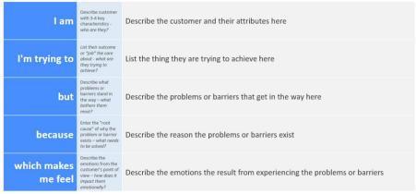

Reference: https://miro.com/templates/customer-problem-statement/

**Example:**



**Which makes me feel**

**Because**

**But**

**I am**

I lack access to affordable technology

Monitor the health and growth of my rice crop

**I’m trying to**

Frustrated and worried about yield

Traditional methods are inefficient

A rice farmer

|  |  |  |  |  |  |
| --- | --- | --- | --- | --- | --- |
| **Problem**  **Statement (PS)** | **I am**  **(Customer)** | **I’m trying to** | **But** | **Because** | **Which makes me feel** |
| PS-1 | A rice farmer | Monitor the health and growth of my rice crop | I lack access to affordable technology | Traditional methods are inefficient | Frustrated and worried about yield |
| PS-2 | An agricultural advisor or consultant | Provide accurate recommendations to farmers | I don’t have real-time, precise data | Crop issues can go undetected too long | Concerned about my credibility |